|  |  |
| --- | --- |
| Ex No: 8  Date: 25/09/2024 | **RNN for Character-Level Name Generation** |

**Objective:**

The objective of this lab is to implement a Recurrent Neural Network (RNN) using Long Short-Term Memory (LSTM) units to generate names from a given dataset of characters. RNNs are designed to handle sequential data, making them ideal for tasks where the order of inputs, such as characters in a name, is important. LSTM units are used to address issues like vanishing gradients, allowing the model to retain information over long sequences. By training on a dataset of names, the model learns patterns in character sequences and uses this knowledge to predict and generate new names that resemble those in the dataset. The ultimate goal is to enable the model to create realistic, unique names by capturing the structural patterns of the names it has learned.

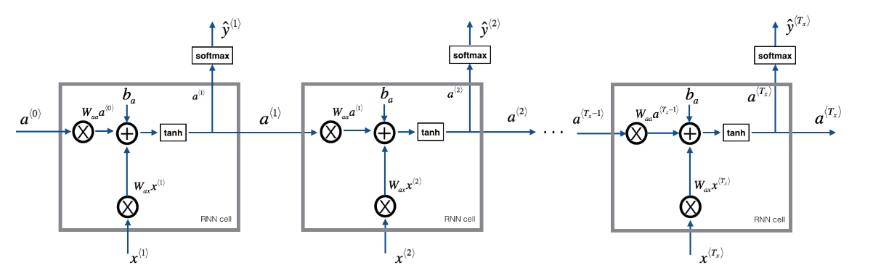

### ****Code Explanation for RNN:****

Imports:

* **numpy**: This library is imported as np and is primarily used for numerical operations, particularly with arrays. It's fundamental for handling mathematical computations efficiently.
* **random**: This module provides functions to generate random numbers, which can be useful for shuffling data or sampling from distributions.
* **matplotlib.pyplot**: Imported as plt, this library is used for creating visualizations and plotting graphs, which can help in visualizing training progress, loss, and other metrics.

### Function: get_initial_loss

* This function is defined to calculate an initial loss value. The parameters vocab_size and dino_names likely indicate the size of the vocabulary and the number of dinosaur names in the dataset.

### Function: optimize

This function performs the optimization step for the model. It takes the input X, labels Y, the previous hidden state a_prev, and the parameters (weights and biases) of the model.

* It likely involves the forward propagation through the neural network to predict outputs and backward propagation to compute gradients for updating the parameters.

**Function: smooth**

* This function is defined to smooth the loss values over iterations. Smoothing helps in reducing the fluctuations in loss values, making it easier to visualize the training process.

### Function: sample

* This function is designed to generate character indices from the model's parameters using a sampling method. It utilizes the char_to_ix dictionary to map characters to indices and the seed for randomization in sampling.

### Function: print_sample

* This function is used to convert the sampled indices back to characters using the ix_to_char dictionary. It likely prints the generated dinosaur names based on the sampled character indices.

### Main Model Function

* This is the main function for training the character-level RNN model. It takes several parameters:
  + vocab_size: The size of the vocabulary used in the model.
  + dino_names: The number of dinosaur names in the dataset.
  + num_iterations: Number of iterations to train the model (default is 10,000).
  + verbose: A flag to control the level of output during training.

**Initialization of Loss:**

* The initial loss is computed by calling get_initial_loss with the vocabulary size and number of dinosaur names. This sets a baseline loss value for training.

**Loading Dinosaur Names**

* This block opens the file "dinos.txt" and reads all the lines (dinosaur names) into the list examples. Each name is converted to lowercase and stripped of whitespace.

**Shuffling Examples**

* Sets a random seed for reproducibility and shuffles the dinosaur names randomly to introduce variability in the training data.

#### Initializing Hidden State

* Initializes the hidden state a_prev of the RNN as a zero vector of shape (n_a, 1), where n_a is the number of hidden units in the LSTM.

#### Optimization Loop

Begins a loop that will iterate num_iterations times for training the model.

#### Index Calculation

* Determines the current index idx by taking the modulo of j with the length of examples. This allows for cycling through the dataset.

#### Preparing Input X

* Retrieves the dinosaur name at index idx and converts it into a list of characters. Then, it maps these characters to their corresponding indices using the char_to_ix dictionary. The input X is created by prepending a None to the list of indices.

#### Preparing Labels Y

* Gets the index of the newline character from char_to_ix and prepares the output labels Y by taking all indices from X except the first one and appending the newline index at the end.

#### Optimization Step

* Calls the optimize function to perform a forward and backward pass with the current input and labels, returning the current loss, computed gradients, and updated hidden state.

**Verbose Output**

* If verbose output is enabled, it prints the iteration index and example index for the first and last iterations. In the first iteration, it also prints the current dinosaur name, its character representation, and the input-output pairs.

**Smoothing Loss**

* Updates the loss by applying the smooth function to track the loss over time and reduce fluctuations.

**Loss Reporting**

* Every 2000 iterations, it prints the current iteration number and the loss value, providing feedback on the training progress.

**Sampling Names**

* Initializes a seed for generating names. It loops through the number of dinosaur names and generates character indices using the sample function, printing the generated names using print_sample. The seed is incremented to generate different results in subsequent iterations.

**Returning Parameters**

* Finally, the function returns the learned model parameters after completing the training iterations.

**Results**

The Recurrent Neural Network (RNN) model effectively learns character sequences and patterns from the provided dataset, allowing it to generate names that resemble those in the training set. At the beginning of the training process, the model's output consists of nonsensical and random combinations of characters. However, as the training progresses and the model becomes more adept at recognizing character patterns, the generated names start to become more structured, realistic, and coherent. The use of Long Short-Term Memory (LSTM) units is particularly beneficial, as they can maintain and pass on relevant information over long sequences of characters. This ability enables the model to capture long-range dependencies between characters, ultimately resulting in the generation of valid, meaningful names that follow the learned linguistic structure.

**Result Analysis:**

During the training process, the model's performance steadily improves as indicated by the decreasing loss value, which shows that the model is becoming more accurate at predicting the next character in a sequence. In the early stages, the predictions might be random or poorly formed, but as the training continues and the model adjusts its parameters through multiple iterations (epochs), it starts to recognize and learn the underlying patterns of the names in the dataset. This results in a gradual refinement of the generated names, with each epoch producing names that are more coherent and realistic. By the end of training, the model has effectively learned to replicate the structure of names, generating sequences that closely resemble the real names it was trained on. This evolution from nonsensical outputs to valid names demonstrates the model's capacity to learn the complex relationships between characters over time and apply that knowledge to synthesize new, plausible names.

**Summary:**

This lab focuses on implementing a character-level Recurrent Neural Network (RNN) using Long Short-Term Memory (LSTM) units to generate names. The model is trained on a dataset containing names, enabling it to learn patterns between individual characters and use this knowledge to create new, realistic names. One of the key techniques employed is **gradient clipping**, which helps maintain stable training by preventing the gradients from becoming too large and disrupting the learning process. The lab effectively demonstrates the capability of RNNs to generate coherent text sequences and underscores the challenges associated with training deep neural networks on sequential data, such as maintaining context and handling long-term dependencies.

**GitHub Link:**

https://github.com/Mithungowda6666/Deeplearning/tree/main/lab_8